San Jose State University

Department of Electrical Engineering

EE250-03
Fall 2017

Midterm 1

Duration: 1 hour

SOLUTION

October 5, 2017

This test consists of four problems.

CLOSED BOOK

Use of one sheet (double sided) of formula is allowed.

Last Name:

First Name:

Student ID:

Problem | Grade
1
2
3
4

Total

Good Luck!

Prof. Kamali

Problem #1 [8 points]: In a processing board, there is an important component (A) whose failure is likely going to result in the failure of the board. Specifically, if A fails, board will fail with the probability of 90%. On the other hand, if A is operational, board fails with the probability of only 5%. Assume A fails with probability of 10%.

- Find the probability of the board’s failure.
- What is the probability that an observed board’s failure has been caused by the failure of A?

Solution:

Board’s failure: B
A’s failure: A

Theorem on total probability:

- Bayes’ Rule:
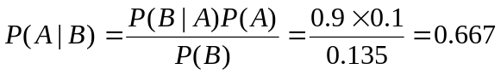

Problem #2 [7 points]: The number of packets arriving at a multiplexer is a Poisson random variable. A graduate student has written a code that records the number of packets that arrive at this multiplexer over many one microsecond intervals. The code shows that in two third of these one microsecond intervals, at least one packet arrives at the multiplexer. What is the average number of packets that arrive at the multiplexer in one microsecond?

Solution:

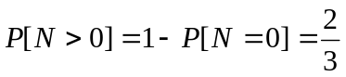

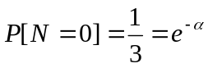

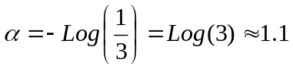

Problem #3 [7 points]: The pdf of a continuous random variable  is given as follows.

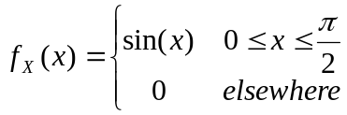

Find 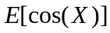.

Solution:

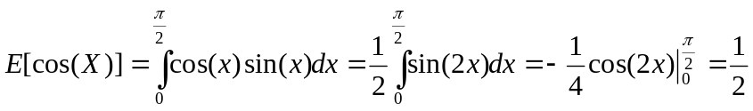

Problem #4 [8 points]: Consider a communication channel whose output is related to its input through the following equation.

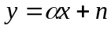

where 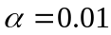is the channel gain and is a zero mean Gaussian noise with the standard deviation of 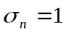mvolt. Input signal is one volt. At the receiver, an Analog to Digital Convertor (ADC) converts to digital. When designing ADC, we fix its input range and when the input signal () exceeds the range of ADC, clipping happens which is undesirable. Find the probability of clipping if the ADC range is 15mvolts.

Q Function
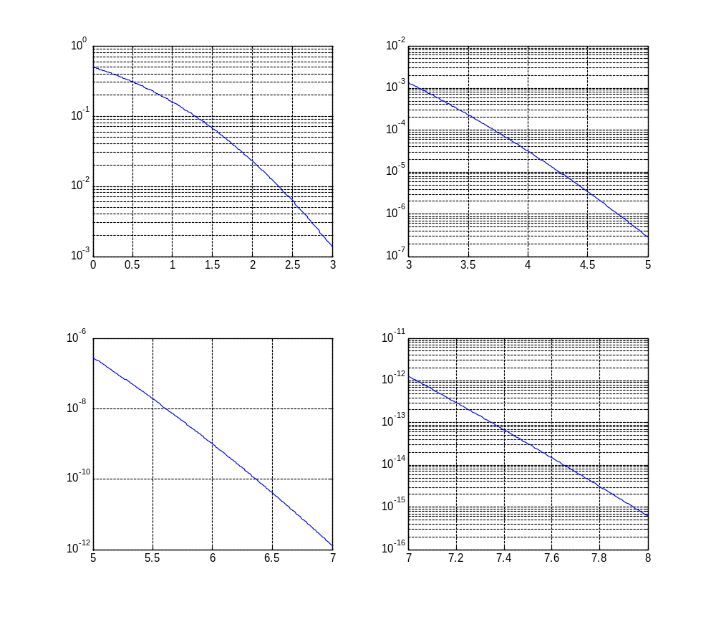
Solution:
Clipping probability: 